What will we be learning?  Unit FO93 – Supporting people with menta; health conditions | Why this? Why now?  This unit is completed in Year 12 in the Spring/Summer. It is a compulsory unit. It runs alongside F090 the examined unit and F091 coursework unit during Year 12. | Key Words/terms:  Stigmas  Stereotypes  Prejudices  Disorders  Hallucinations  Bereavement  Statutory  Non-statutory  Self referral  Practitioners  Legislation  Empathy  Compassion  Advocacy
What will we learn?
- TA1 – Definitions and views of mental health
- TA2 – Mental health conditions
- TA3 – Provision of mental health services
- TA4 – Types of treatment and support for mental health conditions

What opportunities are there for wider study?
Careers/degree courses
- Social care
- Childcare
- Health care

Further reading:
Describe different working relationships in care settings – DSDWEB: FREE STUDY GUIDES FOR CARE QUALIFICATIONS
Timeline of Baby P case - BBC News
Inquiry investigates deaths of 1,500 NHS mental health patients in Essex | Mental health | The Guardian
How will I be assessed?
- OCR set assignments on Teams.
AAQ – HEALTH & SOCIAL CARE
UNIT F093

TA1 – DEFINITIONAND VIEWS OF MENTAL HEALTH  - Key definitions of mental health  - How society views mental health | 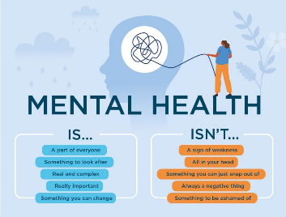
TA2 – MENTAL HEALTH CONDITIONS  2.1 Types of mental health conditions  2.2 Sign and symptoms of mental health conditions  2.3 Individual factors which can increase the risk of suffering from mental health conditions  2.4 Effects of mental health conditions | 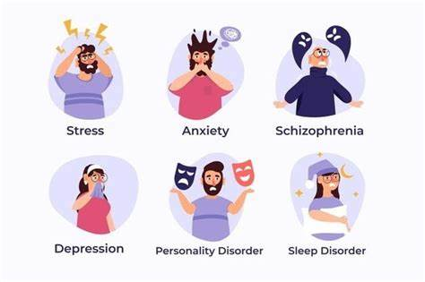
TA3 – PROVISION OF MENTAL HEALTH SERVICES  - Types of provision and mental health services in each type locally and nationally  - Referral to different services  - Practitioners who work in mental health  - Legislation and individual rights relating to mental health | 
TA4 – TREATMENT AND SUPPORT FOR MENTAL HEALTH CONDITIONS  - Types of treatment and support and how they work  - Factors affecting access to treatment and support  - Person-centred approaches to support people with mental health conditions | 